Worksheet (L-6 Changes around us MODULE – 2)

Question 1
Iron rim is made slightly smaller than the wooden wheel. The rim is usually heated before fixing into the wooden wheel, because on heating the iron rim
(a) expands and fits onto the wooden wheel.
(b) contracts and fits onto the wooden wheel.
(c) no change in the size takes place.
(d) expands first, then on cooling contracts and fits onto the wooden wheel.
Question 2
Salt can be separated from its solution (salt dissolved in water), because
(a) mixing of salt in water is a change that can be reversed by heating and melting of salt.
(b) mixing of salt in water is a change that cannot be reversed.
(c) mixing of salt in water is a permanent change.
(d) mixing of salt in water is a change that can be reversed by evaporation.
Question 3
Look at the given figure which shows three situation (a) a burning candle (b) an extinguished candle (c) melting wax.
Which of these shows a reversible change and why?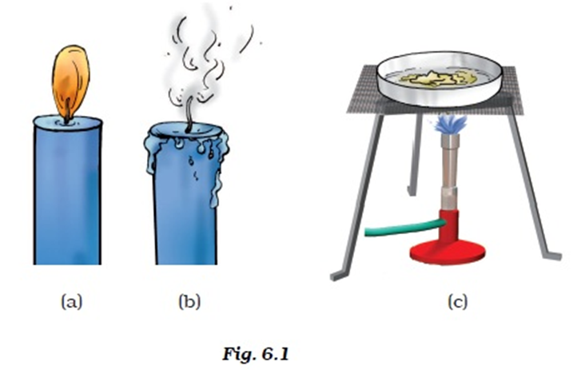
Question 4
A piece of iron is heated till it becomes red-hot. It then becomes soft and is beaten to a desired shape. What kind of changes are observed in this process– reversible or irreversible?
Question 5
Paheli had bought a new bottle of jam from the market. She tried to open the metal cap to taste it but could not do so. She then took a bowl of hot water and immersed the upper end of the bottle in it for five minutes. She could easily open the bottle now. Can you give the reason for this?
Question 6
Describe the process of formation of curd from milk. whether the change happened in milk can be reversed?
Question 7
Tearing of paper is said to be a change that cannot be reversed. What about paper recycling?
Question 8
Give one example in each case
(a) Change which occurs on heating but can be reversed.
(b) Change which occurs on heating but cannot be reversed.
(c) Change which occurs on cooling but can be reversed.
(d) change which occurs very fast but cannot be reversed.
(e) Change which occurs on mixing two substances, but can be reversed.
(f) Change which occurs on mixing two substances, but cannot be reversed.
Question 9
(a) If we sharp a pencil its length decreases. Can this change be reversed? [yes/no]
(b) Biogas is prepared from cow dung. Can this change be reversed? [yes/no]
Question 10
Choose the correct word from the bracket and fill in the blanks.
- Cooling causes the material to _________. [expand/contract]
- Sometimes the tyre tube of a cycle bursts in a hot weather because the air in the tyre _________. [expand/contract]
- _________ expands the least while gases expand the most. [solids/liquids]
- Gaps are kept at the joints of railway tracks because of the expansion of tracks during ________ weather. [hot/cold]
- Digestion of food is a/ an __________ change. [reversible/irreversible]
- Formation of dew drops in the morning is an example of ___________ change. [reversible/irreversible]

Girija Pal
TGT, AECS 1, Mumbai

